Transaction Trigger Tracker User Guide

Team 1

April 26, 2020

Team Members
Tarsus Arciga
Long Dang
Dalton Gilmore
Ekrem Kalabak
Alexa Summers

Contents

Contents 2
1 Introduction 3
2 Quick Start Guide 3
3 System Requirements 4
4 Main Scenarios of Use 4
5 Troubleshooting 8

Introduction
The Transaction Trigger Tracker web application will allow Commerce Bank clients to log into their banking account to view past transactions, see notifications, and set/edit triggers for certain types of transactions. This document will provide instructions for using the application to view transactions, set triggers, edit triggers, and view notifications.

Quick Start Guide
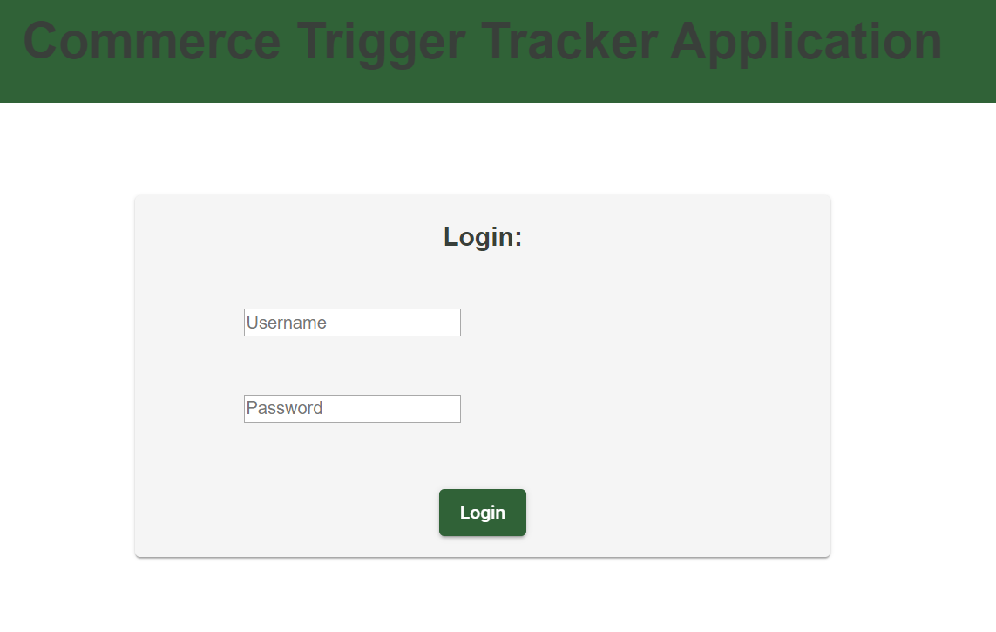
- Navigate to the Trigger Tracker application, and login using your Commerce Bank credentials.
- Dashboard will be displayed. This is the central access point for all navigation points. The list of transactions will be displayed.
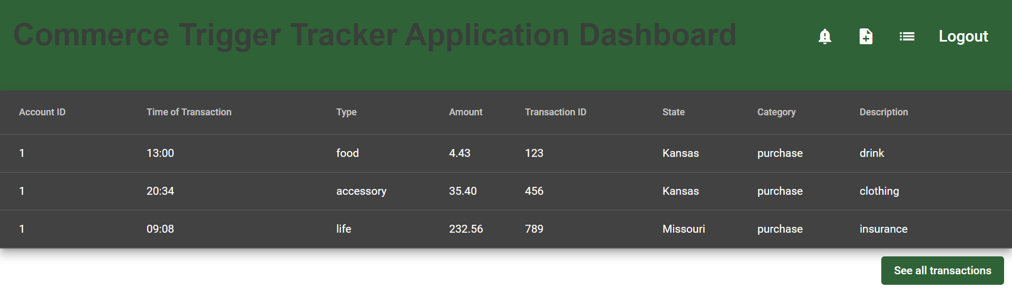

System Requirements
The Transaction Trigger Tracker web application should be accessed on an internet accessible web browser from either computer or mobile device. Refer to the System Documentation for instructions on accessing.

Main Scenarios of Use

Add New Trigger
- Log into the web application with your Commerce Bank credentials.
- Click “Login”.
- Select the “Add New Trigger” button.
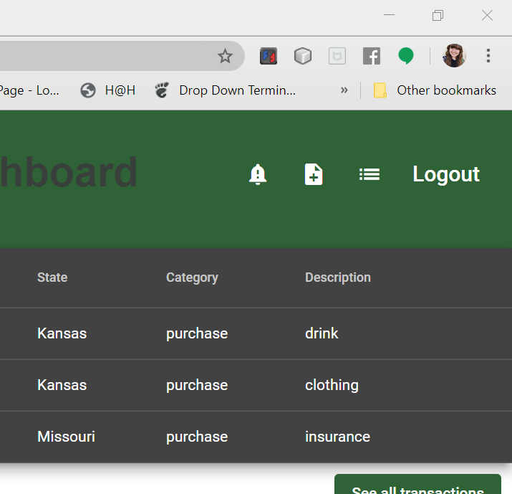

- Select the desired type for the new trigger.
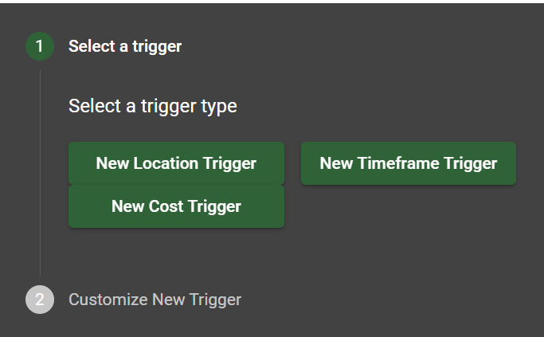

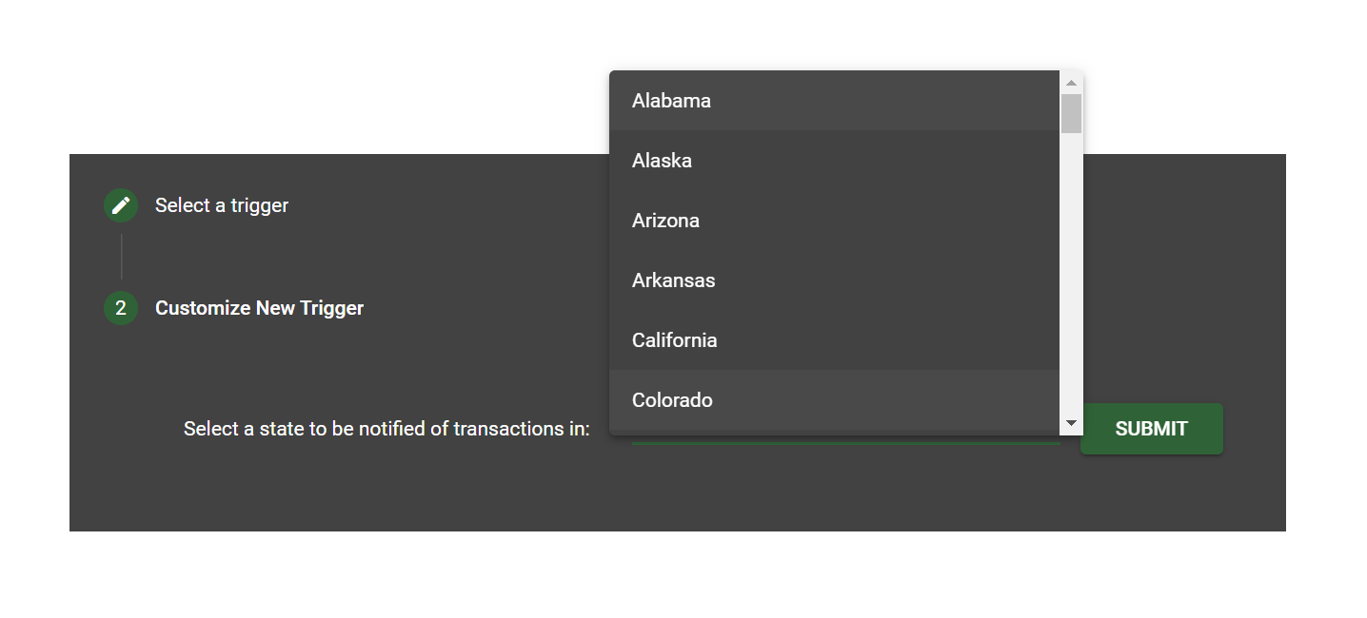
- Customize the settings for the chosen trigger type.
For Location Trigger: Select the desired state from the drop down menu, and click “Submit”.
For Timeframe Trigger: Select the desired start time and end time from the drop down menus, and click “Submit”.
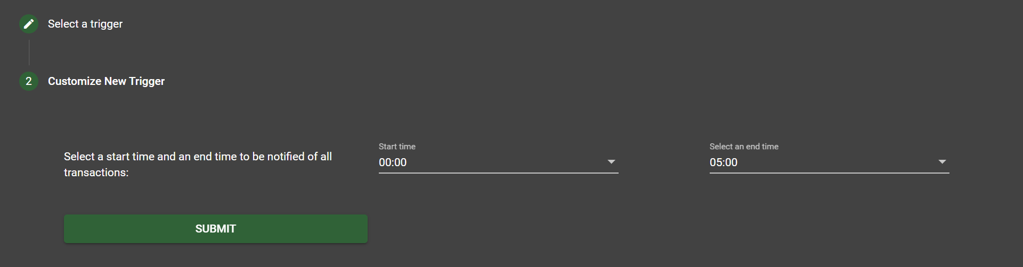
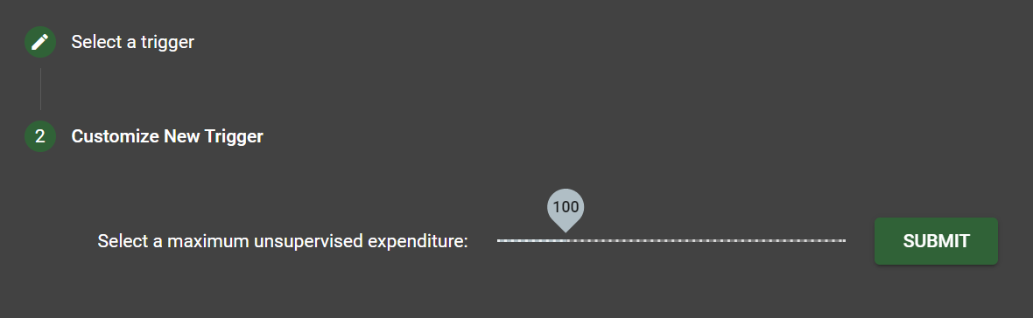
For Cost Trigger: Select a maximum unsupervised expendeture by dragging the slider to the desired amount, and click “Submit”.

Edit Old Triggers
- Log into the web application with your Commerce Bank credentials.
- Tap the “View Triggers” icon.

- Click the edit icon next to the trigger you wish to edit.
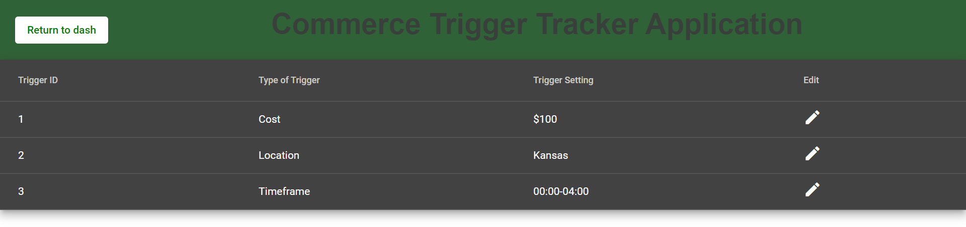
- Edit the trigger preferences.
For location trigger: Select the new desired state from the drop down menu, and click “Submit”.

For timeframe trigger: Select the newly desired start time and end time from the drop down menus, and click “Submit”.
For Cost Trigger: Select a new maximum unsupervised expendeture by dragging the slider to the desired amount, and click “Submit”.

View Notifications
  - Log into the web application with your Commerce Bank Credentials.
  - Click the “View Notifications” icon.

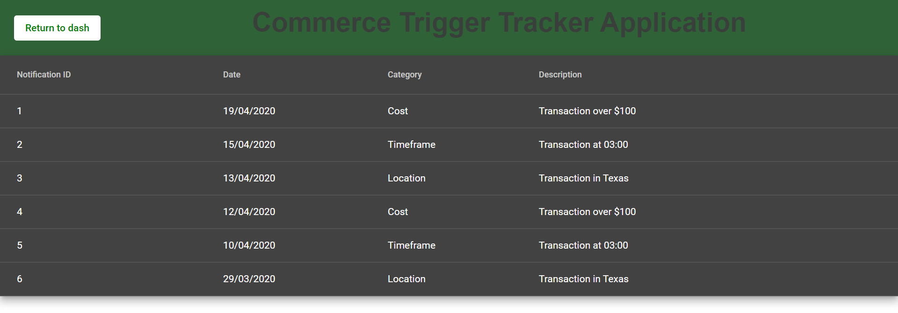
  - View notifications generated by tripped triggers.

Troubleshooting

Missing or Incorrect Password or Username
A message will display in the event of incorrect credentials being used in an attempt to log into the web application.

Navigated to the Wrong Page
There is a “return to dash” button on every page located up in the tool bar. This will bring you back to the home page (user dashboard).

